Lab Report No 4

Implementation of Gray Level Transformation
Digital Image Processing



Submitted By:
[Huzaifa Shahbaz]
[21-CE-009]
[Aqsa Shah]
[21-CE-039]
Submitted to:
Engr. Hareem Khan
Dated:
24thOct,2024

Department of Computer Engineering,
HITEC University, Taxila
Lab Example No 1:

Solution:
Brief description (3-5 lines)
Contrast stretching is a simple image enhancement technique that attempts to improve the contrast in an image by `stretching' the range of intensity values it contains to span a desired range of values. Normally (min, max) → (0, 255)
The code
import cv2
import numpy as np
import matplotlib.pyplot as plt
# Load the image in grayscale
image = cv2.imread('Screenshot 2024-10-26 114803.jpeg', 0)
r_min, r_max = np.min(image), np.max(image)
contrast_stretched = (image - r_min) * (255 / (r_max - r_min))
# Normalize to [0, 255]
contrast_stretched = np.array(contrast_stretched, dtype=np.uint8)
plt.subplot(1, 2, 1)
plt.title('Original Image')
plt.imshow(image, cmap='gray')
# Display the result
plt.subplot(1, 2, 2)
plt.imshow(contrast_stretched, cmap='gray')
plt.title('Contrast Stretching')
plt.tight_layout()
plt.show()
The results (Screenshot)
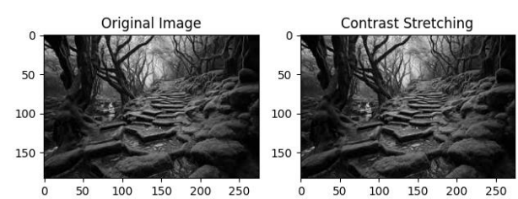

Lab Example No 2:

Solution:
Brief description (3-5 lines)
Thresholding is the operation through which an image can be converted into a binary image/black & white i.e. having only two distinct levels. Threshold value can be the mean or median etc. of the image. Each pixel is compared to a threshold value:
- Pixels greater than the threshold are set to one value (e.g., 255).
- Pixels below the threshold are set to another value (e.g., 0).
The code
import cv2
import numpy as np
import matplotlib.pyplot as plt
# Load the image in grayscale
image = cv2.imread('Screenshot 2024-10-26 122352.jpeg', 0)
# Apply simple thresholding
# Threshold at 127, values above 127 are set to 255, below are set to 0
_, binary_image = cv2.threshold(image, 127, 255, cv2.THRESH_BINARY)
# Apply inverse binary thresholding
_, binary_inv_image = cv2.threshold(image, 127, 255, cv2.THRESH_BINARY_INV)
# Display original and thresholded images
plt.figure(figsize=(10, 5))
plt.subplot(1, 3, 1)
plt.imshow(image, cmap='gray')
plt.title('Original Image')
plt.axis('off')
plt.subplot(1, 3, 2)
plt.imshow(binary_image, cmap='gray')
plt.title('Binary Thresholding')
plt.axis('off')
plt.subplot(1, 3, 3)
plt.imshow(binary_inv_image, cmap='gray')
plt.title('Inverse Binary Thresholding')
plt.axis('off')
plt.tight_layout()
plt.show()
The results (Screenshot)
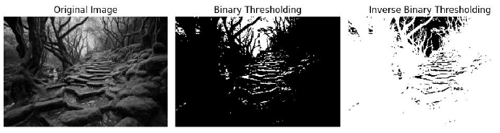
Lab Example No 3:

Solution:
Brief description (3-5 lines)
Gray level Slicing is used to highlight a specific range of gray levels in an image. It can either:
Highlight a specific intensity range while keeping other intensities intact.
Highlight a specific intensity range while suppressing all other intensities to black (0).
The code
import cv2
import numpy as np
import matplotlib.pyplot as plt
# Load the image in grayscale
image = cv2.imread('Screenshot 2024-10-26 122930.png', cv2.IMREAD_GRAYSCALE)
# Define the gray-level slicing function
def gray_level_slicing(image, min_val, max_val, slice_value):
# Create an output image filled with zeros (black)
output_image = np.zeros_like(image)
# Set the pixel values within the specified range to the slice_value
output_image[(image >= min_val) & (image <= max_val)] = slice_value
return output_image
# Apply gray-level slicing to highlight pixels in the range [100, 200]
sliced_image = gray_level_slicing(image, 100, 200, 255)
# Display original and gray-level sliced images
plt.figure(figsize=(10, 5))
plt.subplot(1, 2, 1)
plt.imshow(image, cmap='gray')
plt.title('Original Image')
plt.axis('off')
plt.subplot(1, 2, 2)
plt.imshow(sliced_image, cmap='gray')
plt.title('Gray Level Slicing')
plt.axis('off')
plt.tight_layout()
plt.show()
The results (Screenshot)
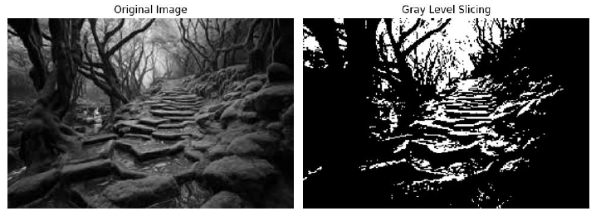
Lab Example No 4:

Solution:
Brief description (3-5 lines)
Transformation operations help enhance the quality of the image by applying operations like log, inverse log and power on the entire image. Different type of transformation yields different results.
1. Power-Law (Gamma) Transformation
Gamma correction is used for adjusting brightness. The formula of power or gamma transformation is:
S=c.r^{y}
where c and gamma are constant.
The code
import cv2
import numpy as np
import matplotlib.pyplot as plt
def gamma_correction(image, gamma):
# Normalize the image to range [0, 1]
normalized_image = image / 255.0
# Apply the gamma correction
gamma_corrected = np.power(normalized_image, gamma)
# Scale back to [0, 255]
gamma_corrected = np.uint8(gamma_corrected * 255)
return gamma_corrected
# Load the image in grayscale
image = cv2.imread('download.jpeg', 0)
# Define different gamma values for experimentation
gamma_values = [0.5, 1.0, 1.5, 2.0]
# Plot original and gamma corrected images
plt.figure(figsize=(12, 8))
# Display original image
plt.subplot(2, 3, 1)
plt.imshow(image, cmap='gray')
plt.title('Original Image')
plt.axis('off')
# Apply Gamma Transformations for each gamma value
for i, gamma in enumerate(gamma_values):
gamma_image = gamma_correction(image, gamma)
# Display the gamma corrected image
plt.subplot(2, 3, i + 2)
plt.imshow(gamma_image, cmap='gray')
plt.title(f'Gamma = {gamma}')
plt.axis('off')
plt.tight_layout()
plt.show()
The results (Screenshot)
Lab Example No 5:

Solution:
Brief description (3-5 lines)
Log transformation enhances darker pixels in an image. The formula of log transformation is:
s=c*log(1+r)
where c is a scaling constant and r is the pixel intensity.
c = 255 / log(1 + rmax )
The code
import cv2
import numpy as np
import matplotlib.pyplot as plt
# Load the image in grayscale
image = cv2.imread('download.jpeg', 0)
c = 255 / np.log(1 + np.max(image))
log_transformed = c * (np.log(1 + image))
# Normalize to [0, 255]
log_transformed = np.array(log_transformed, dtype=np.uint8)
# Display the result
plt.subplot(1, 2, 1)
plt.title('Original Image')
plt.imshow(image, cmap='gray')
plt.subplot(1, 2, 2)
plt.imshow(log_transformed, cmap='gray')
plt.title('Log Transformation')
plt.tight_layout()
plt.show()
The results (Screenshot)

Lab Example No 6:

Solution:
Brief description (3-5 lines)
Image Negative:
This technique inverts the intensity of pixels. The formula for inverse transformation is:
s=(L-1)-r
where L is the maximum pixel value, typically 256 for 8-bit images.
The code
import cv2
import numpy as np
import matplotlib.pyplot as plt
# Load the image in grayscale
image = cv2.imread('download.jpeg', 0)
# Perform negative transformation
negative_image1 = 255 - image
# Perform negative operation using cv2.bitwise_not()
negative_image2 = cv2.bitwise_not(image)
# Display original and negative image
plt.subplot(3, 1, 1)
plt.title('Original Image')
plt.imshow(image, cmap='gray')
plt.subplot(3, 1, 2)
plt.title('Negative Image After subtracting from L=255')
plt.imshow(negative_image1, cmap='gray')
plt.subplot(3, 1, 3)
plt.title('Negative Image using cv2.bitwise_not()')
plt.imshow(negative_image2, cmap='gray')
plt.tight_layout()
plt.show()
The results (Screenshot)

Lab Task No 1:

Solution:
Brief description (3-5 lines)
Apply contrast stretching on the image provided in lab by setting 5th and 95th percentiles of the input values to 0 and 255 respectively.
The code
import cv2
import numpy as np
import matplotlib.pyplot as plt
# Load the image
img = cv2.imread('Screenshot 2024-10-26 122930.jpg', 0)
# Calculate the 5th and 95th percentiles
p5 = np.percentile(img, 5)
p95 = np.percentile(img, 95)
# Apply contrast stretching
stretched_img = np.clip((img - p5) * (255 / (p95 - p5)), 0, 255).astype(np.uint8)
# Display the original and stretched images
plt.figure(figsize=(10, 5))
plt.subplot(1, 2, 1)
plt.imshow(img, cmap='gray')
plt.title('Original Image')
plt.axis('off')
plt.subplot(1, 2, 2)
plt.imshow(stretched_img, cmap='gray')
plt.title('Contrast Stretched Image')
plt.axis('off')
plt.tight_layout()
plt.show()
The results (Screenshot)
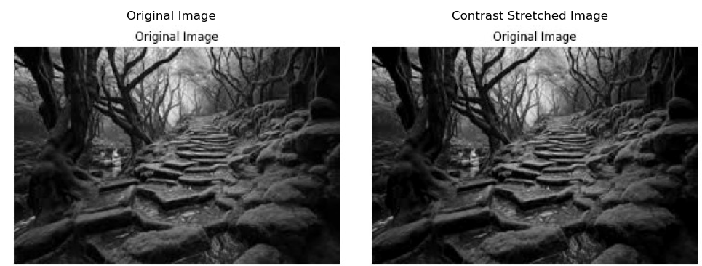

Lab Task No 2:

Solution:
Brief description (3-5 lines)
Apply the following transformation on an contrast enhanced image.
 | Pixel values range | Output pixel value
a) | Less than mean  Greater than mean | 0  255
b) | Less than mean  Greater than mean | 255  0
c) | ±20 mean  Otherwise | 0  255

The code
import cv2
import numpy as np
# Load the image
image = cv2.imread('Screenshot 2024-10-26 200104.jpg', cv2.IMREAD_GRAYSCALE)
# Enhance contrast
enhanced_image = cv2.equalizeHist(image)
# Calculate the mean pixel value
mean = np.mean(enhanced_image)
# Apply the transformation
# Option a)
transformed_image_a = np.where(enhanced_image < mean, 0, 255).astype(np.uint8)
# Option b)
transformed_image_b = np.where(enhanced_image < mean, 255, 0).astype(np.uint8)
# Option c)
transformed_image_c = np.where(np.abs(enhanced_image - mean) <= 20, 0, 255).astype(np.uint8)
# Display the results
cv2.imshow('Original Image', image)
cv2.imshow('Enhanced Image', enhanced_image)
cv2.imshow('Transformed Image (Option a)', transformed_image_a)
cv2.imshow('Transformed Image (Option b)', transformed_image_b)
cv2.imshow('Transformed Image (Option c)', transformed_image_c)
cv2.waitKey(0)
cv2.destroyAllWindows()
The results (Screenshot)
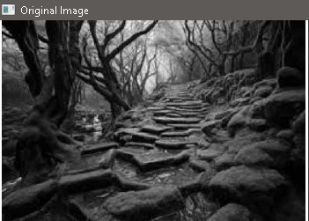
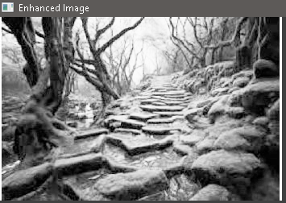
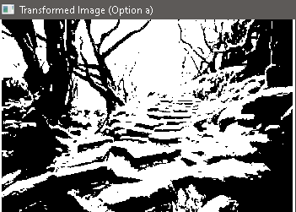
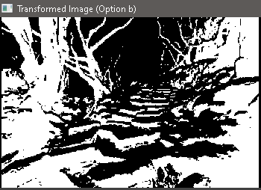
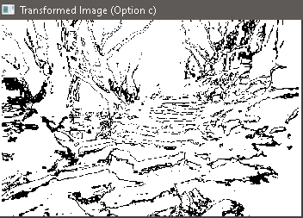

Lab Task No 3:

Solution:
Brief description (3-5 lines)
After obtaining constrast streatched images from task 1 .
Apply Power Law transformation for the following values of γ (0.2, 0.5, 1.2 and 1.8) . Make sure to adjust data types accordingly
The code
import cv2
import numpy as np
# Load the image
img = cv2.imread('Screenshot 2024-10-26 200104.jpg', cv2.IMREAD_GRAYSCALE)
# Define the gamma values
gamma_values = [0.2, 0.5, 1.2, 1.8]
# Apply Power Law transformation for each gamma value
for gamma in gamma_values:
# Convert image to float type
img_float = img.astype(np.float32) / 255.0
# Apply Power Law transformation
img_gamma = np.power(img_float, gamma)
# Convert image back to uint8 type
img_gamma = (img_gamma * 255.0).astype(np.uint8)
# Display the image
cv2.imshow(f'Gamma: {gamma}', img_gamma)
cv2.waitKey(0)
# Close all windows
cv2.destroyAllWindows()
The results (Screenshot)
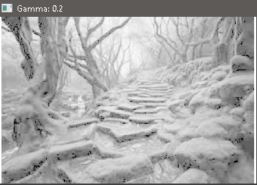
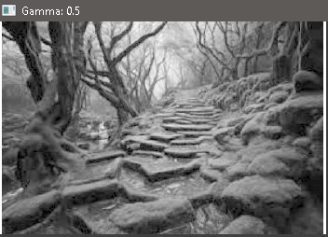
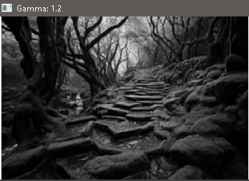
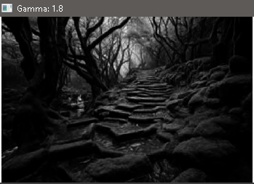
Conclusion
In conclusion, Gray Level Transformations improve image processing by adjusting brightness, contrast, and detail visibility in grayscale images. Techniques like linear, logarithmic, and power-law transformations enhance pixel intensities, improving visual interpretation. This computationally efficient and adaptable method is crucial in fields like medical imaging and remote sensing for high-quality image analysis.

